

National College of Ireland

Project Submission Sheet

Student Name: | Surya Chandra Raju Kurapati, Saranya Munikannaiah, Yathish Juttu Rajkumar
Student ID: | x233969620, x23434821, x23389818
Programme: | MSc in Data Analytics (MSCDAD_B) | Year: | Jan 2025-2026
Module: | Business Intelligence & Business Analytics
Lecturer: | Vikas Sahni
Submission Due Date: | 03-Aug-2025
Project Title: | Optimizing B2B Sales Outreach at LinkedIn using Job Activity Signals and Lead Scoring
Word Count: | 5327 words

I hereby certify that the information contained in this (my submission) is information pertaining to research I conducted for this project. All information other than my own contribution will be fully referenced and listed in the relevant bibliography section at the rear of the project.
ALL internet material must be referenced in the references section. Students are encouraged to use the Harvard Referencing Standard supplied by the Library. To use other author's written or electronic work is illegal (plagiarism) and may result in disciplinary action. Students may be required to undergo a viva (oral examination) if there is suspicion about the validity of their submitted work.

Signature: | Surya Chandra Raju Kurapati, Saranya Munikannaiah, Yathish Juttu Rajkumar
Date: | 03-Aug-2025

PLEASE READ THE FOLLOWING INSTRUCTIONS:

1. Please attach a completed copy of this sheet to each project (including multiple copies).
2. Projects should be submitted to your Programme Coordinator.
3. You must ensure that you retain a HARD COPY of ALL projects, both for your own reference and in case a project is lost or mislaid. It is not sufficient to keep a copy on computer. Please do not bind projects or place in covers unless specifically requested.
4. You must ensure that all projects are submitted to your Programme Coordinator on or before the required submission date. Late submissions will incur penalties.
5. All projects must be submitted and passed in order to successfully complete the year. Any project/assignment not submitted will be marked as a fail.

Office Use Only
Signature:
Date:
Penalty Applied (if applicable):

AI Acknowledgement Supplement

Data Intensive and Scalable Systems

Healthcare Insurance Claims Processing: Leveraging Big Data for Policy Renewal Analysis (Descriptive Analytics) and Fraud Detection (predictive Analytics)

Your Name/Student Number | Course | Date
Surya Chandra Raju Kurapati | MSc in Data Analytics | 03-Aug-2025
Saranya Munikannaiah | MSc in Data Analytics | 03-Aug-2025
Yathish Juttu Rajkumar | MSc in Data Analytics | 03-Aug-2025

This section is a supplement to the main assignment, to be used if AI was used in any capacity in the creation of your assignment; if you have queries about how to do this, please contact your lecturer. For an example of how to fill these sections out, please click here.

AI Acknowledgment
This section acknowledges the AI tools that were utilized in the process of completing this assignment.
Tool Name | Brief Description | Link to tool
ChatGPT | Used to understand Business terminologies and key concepts | https://chatgpt.com/

Description of AI Usage
This section provides a more detailed description of how the AI tools were used in the assignment. It includes information about the prompts given to the AI tool, the responses received, and how these responses were utilized or modified in the assignment. One table should be used for each tool used.
[Insert Tool Name]
Upon collecting various sources and references relevant to speech recognition and text to vector conversion, used ChatGPT to study various content, key objectives of the use case.
Terminologies used in every stage of CRM from leads to win status. | | 2. Lead Qualification | SQL (Sales Qualified Lead) | A lead vetted by sales as a good fit. |  | | Lead Score | A numerical value assigned based on behavior, demographics, activity. |  | | BANT / CHAMP / MEDDIC | Frameworks used to qualify leads (e.g., Budget, Authority, Need, Timing). |  | | Prospect | A qualified lead likely to convert. |  | 3. Opportunity Management| Opportunity | A deal in progress; potential revenue tracked in CRM. |  | | Deal Stage | Sales phase (e.g., Demo Scheduled, Proposal Sent, Negotiation). |  | | Pipeline | Visual representation of all opportunities and their deal stages. |  | | Account | The company or organization linked to the opportunity. |  | | Contact | The specific person you're interacting with within the account. |  | 4. Conversion / Closing | Closed-Won | Successful conversion – the deal is won and customer onboarded. |  | | Closed-Lost | Opportunity was not won (e.g., prospect chose competitor). |  | | Deal Size / Contract Value | Monetary value of the opportunity. |  | | Expected Close Date | Predicted date the deal is likely to be finalized. |

Evidence of AI Usage
This section includes evidence of significant prompts and responses used or generated through the AI tool. It should provide a clear understanding of the extent to which the AI tool was used in the assignment. Evidence may be attached via screenshots or text.
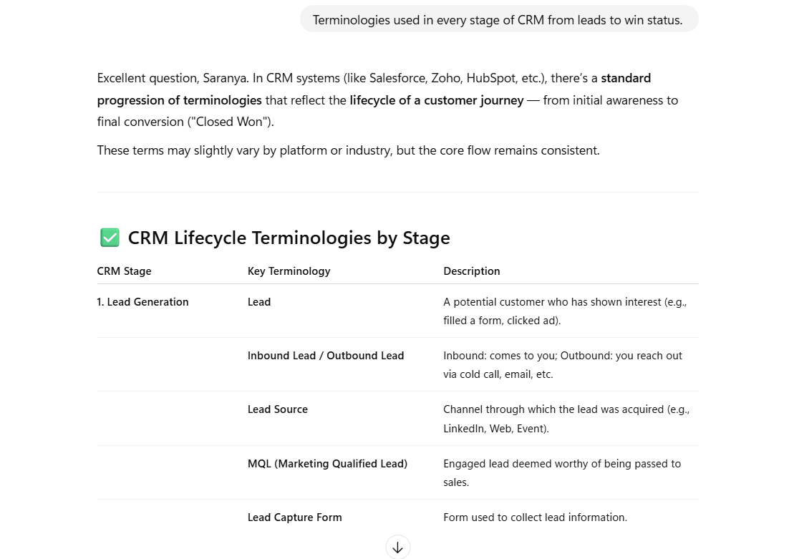

Additional Evidence:
[Place evidence here]

Additional Evidence:
[Place evidence here]

Optimizing B2B Sales Outreach at LinkedIn using Job Activity Signals and Lead Scoring

Surya Chandra Raju Kurapati
Master of Science in Data Analytics, School of Computing,
National College of Ireland
Dublin, Ireland
x233969620@student.ncirl.ie

Saranya Munikannaiah
Master of Science in Data Analytics, School of Computing,
National College of Ireland
Dublin, Ireland
x23434821@student.ncirl.ie

Yathish Juttu Rajkumar
Master of Science in Data Analytics, School of Computing,
National College of Ireland
Dublin, Ireland
x23389818@student.ncirl.ie

Abstract – LinkedIn, a global leader in professional networking and talent acquisition, maintaining active partnerships with approximately 25,000 employers across the United States, is facing operational and financial inefficiencies within its job posting ecosystem. Despite high visibility of job listings averaging around 15 views per posting, conversion rates remain low, with only 2 applications submitted per job. This has resulted in underutilized job inventory, listings expiring within 30 days, and growing dissatisfaction among employer clients.
This report presents a comprehensive business transformation project undertaken for LinkedIn, aimed at improving its B2B sales performance through data-driven strategies. The goal of this project is to deliver an end-to-end solution using business intelligence and analytics, beginning with the integration of fragmented infrastructure records into the CRM system and followed by the analysis of employer job activity signals, such as posting frequency, viewership rate, and hiring trends through BI dashboards to better target leads for sponsorship and identify upselling opportunities. This model focuses on high-intent employer accounts and is integrated directly into Salesforce CRM, where the major sales entities such as Accounts, Contacts, Leads, and Opportunities are framed for ideal tracking and workflow.
A comprehensive SWOT analysis directed the strategic solution by emphasizing both internal weaknesses and external opportunities, while a Continuous Improvement Program based on the Plan-Do-Check-Act (PDCA) methodology ensured that the solution remained adaptable and responsive during its development. Aligning with LinkedIn's strategic goals, a Balanced Scorecard framework was leveraged to define key performance indicators along financial, customer, internal processes, and growth perspectives. The final solution consisted of three Tableau dashboards focused on Job Performance, User Behavior, and Alerts, which provided real-time visibility into performance trends, areas requiring improvement, and opportunities for ROI maximization. Together, these tools and frameworks allowed LinkedIn's teams to operate more strategically: enabling sales and account reps to actively track employer engagement and upsell premium listings, providing recruiters with real-time insights and automated recommendations via embedded Tableau dashboards, helping the marketing team to launch targeted retention and sponsorship campaigns, and providing executives with overall visibility into platform performance, client attrition, ROI, and engagement metrics.
Keywords - B2B (Business to Business model), SWOT, PDCA, Balance Scorecard, CIP (Continuous Improvement Process), CRM (Customer Relationship Management), Salesforce, Tableau, Sales.

PROJECT SPECIFICATION REPORT
- BUSINESS OVERVIEW AND SERVICES
LinkedIn is the world’s leading professional networking platform, operating at the intersection of technology, recruitment, and digital business services. Its business model serves both B2C customers such as job seekers, professionals, and learners, and B2B customers such as employers, recruiters, and advertisers. On the consumer side, LinkedIn allows individuals to create professional profiles, network with peers, find learning opportunities, and job apply. On the enterprise side, it provides Talent Finding Solutions, Recruiter Subscriptions, Job Advertising, and Sales Navigator to enable companies to recruit talent, advertise to target audiences, and manage relationships.
LinkedIn’s B2B recruitment segment is especially data-rich and active, with over 25,000 employer partnerships across the United States, offering job roles from entry-level to director-level across industries such as Healthcare with 30% followed by Retail and IT with 16% job offerings. The platform supports a wide range of job types including full-time, contract, internship, part-time, and temporary roles with full-time jobs dominating with 80% of listings. States like New York stand out with the highest platform reach, recording over 800K job listing views, contributing to the overall high viewership rate of approximately 15 views per job posting.
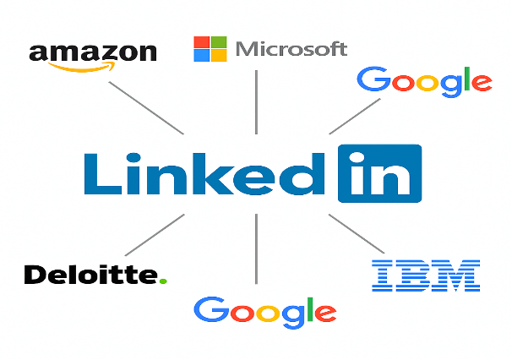
Figure 1: LinkedIn partners and premium clients
In addition, LinkedIn offers a two-part recruitment solution consisting of Sponsored Job Ads based on a pay-per-click mechanism to boost search result visibility and LinkedIn Talent Solutions, an add-paid suite providing access to advanced sourcing tools, candidate information, and analytics dashboards. Together, the offerings allow employers to tailor the recruitment strategy in terms of urgency, volume, and targeting degree.
Despite this size and profile, LinkedIn's B2B recruitment system is faced with mounting operational and fiscal inefficiencies. The gap between views and actual job applications is found to be just 2 per posting on average which has resulted in underutilized listings, expiring posts, and client dissatisfaction.
Internally, disjointed CRM systems, limited insight into employer behavior, and the lack of lead prioritization have hindered sales efficiency. In response to these issues, LinkedIn is focusing on data-driven approaches to optimize its B2B business. This approach includes the use of business intelligence and analytical tools to assess job activity signals, develop predictive lead scoring models, and determine high-intent opportunities. With more integration with Salesforce CRM and increased visibility through real-time Tableau dashboards, LinkedIn aims to optimize targeting, streamline sales processes, and improve return on investment for its recruitment partners.

- MARKET PLACE AND COMPETITION
LinkedIn operates in an intensely competitive market of recruitment and professional networking globally, where it has a strong presence by combining social connectivity with professional identity. It is heavily used by recruiters and employers for talent discovery, lead nurturing, and outreach through integrated tools like Sales Navigator and Talent Solutions. However, LinkedIn competes with well-known platforms in the United States, such as Indeed, ZipRecruiter, Glassdoor, Handshake, and Workday, with each offering unique strengths as explained in Table 1. Indeed remains a major competitor with its vast number of job postings and easy-to-use interface, especially known for its one-click "Easy Apply" feature, which appeals to job candidates who prefer convenience. ZipRecruiter focuses on AI-powered job matching and simplified employer workflows, while Glassdoor focuses on company reviews and candidate research. In contrast, Handshake carves out a specialized niche in student and early-career recruitment.
The above alternatives offer effective and cost-effective solutions for organizations seeking to attract top talent. As a result, LinkedIn's customer base is increasingly fragmented, with employers often opting to post job ads on multiple sites to gain broader reach and improve candidate quality. This trend underscores the need for LinkedIn to improve its data-driven capabilities and value proposition to stay ahead in terms of reach as well as relevance.
Table 1: Competitive Landscape
Platform | Strengths | Weaknesses
LinkedIn | Large professional network, B2B integrations | Low application-to-view ratio, underutilized job inventory
Indeed | Massive job volume, popular for one-click "Easy Apply" jobs | Lacks professional networking, limited lead scoring or targeting tools
ZipRecruiter | AI-driven matching, employer-friendly UX, broad distribution network | Less control over applicant quality, basic analytics
Glassdoor | Strong employer branding, transparent reviews, good for company research | Not optimized for applying, lacks CRM or advanced outreach features
Handshake | University partnerships, strong for early-career talent, streamlined campus tools | Limited scope beyond entry-level, smaller overall user base
- CURRENT BUSINESS PROBLEM
Despite LinkedIn's solid presence in career networking and recruitment, several crucial issues are impacting the performance and profitability of its B2B job posting and recruitment sphere. The consulting team, under the Business Intelligence and Business Analytics (BIBA) initiative, has identified the following pain points as illustrated in Figure 2, based on platform data, client behavior, and operational insights:
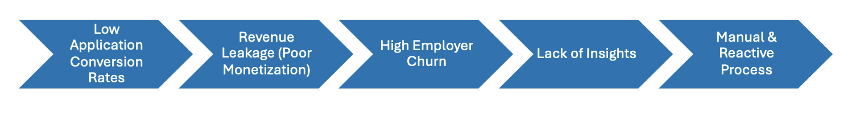
Figure 2: Business Problem
- Low Application Conversion Rates: Job postings receive ~15 views per listing, reflecting strong traffic and visibility. However, the platform is getting only approximately ~2 applications per job, that is ~ 13.3% which is a low conversion rate for the views of each job.
- Revenue Leakage: Although LinkedIn operates on multifaced business model such as Sponsored Job Ads on a pay-per-click basis and Talent Solutions as a subscription product the revenue generation from these operations remains low and inconsistent. Many job postings are not promoted, and ~95% of employers underutilize available premium tools. This leads to missed revenue opportunities, especially when listings with hiring urgency are not surfaced to top-tier candidates due to lack of promotion.
- High Employer Churn: A noticeable increase in churn particularly among mid-market clients reflects growing dissatisfaction with the platform’s value proposition. Many employers feel they aren’t seeing adequate returns from paid ads or recruitment tools, a concern amplified by weak application-to-view conversion rates and a lack of performance transparency. Application data further reveals that only 6.65% of applicants use the Easy or Quick Apply option, while 66.68% apply through standard or detailed forms and 26.67% are redirected to external sites, suggesting that lengthy or complex application flows may be discouraging candidates ultimately impacting employer satisfaction, job fill rates, and client renewal decisions.
- Lack of Insights: LinkedIn's sales and account teams currently face significant hurdles in getting timely, actionable insights. The platform lacks real-time information via performance dashboards that effectively encapsulate key dimensions like user behavior, trends in employer engagement, and the performance of job listings. Additionally, the absence of automated alerts for underperforming areas such as jobs nearing expiry or accounts with low engagement. This insight gap leaves the organization resulting in missed opportunities to create high-value leads, drive upselling, or improve client retention.
- Manual & Reactive Process: The current process of identifying client issues, suggesting improvements, or tracking job performance is largely manual and prone to delays. Sales reps often rely on fragmented CRM data and ad hoc client intuition rather than methodical analytical information. Without automatic lead analysis, behavioural segmentation, or adaptive outreach processes, sales efforts continue to be inefficient and inconsistent across accounts.
- BUSINESS GOALS & STRATEGY
To deal with the current challenges, the team suggests a comprehensive solution based on Business Intelligence (BI) and Business Analytics (BA) concepts, with the objective of shifting LinkedIn's B2B business from a reactive to a proactive one.
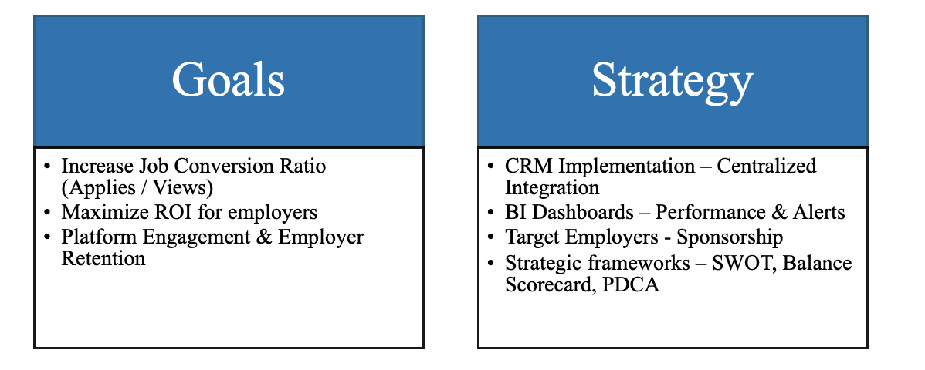
Figure 3: Business Goals & Strategy
As illustrated in Figure 3, the primary business objectives are to drive up the job conversion ratio (applications per view), achieve maximum return on investment for employers, and enhance overall platform engagement and client retention. To achieve these objectives, the strategy is centered around three pillars: the adoption of a centralized CRM system for consolidated data tracking and sales management, the use of real-time Tableau dashboards to track performance, user behavior, and trigger alerts for underperforming segments, and the application of strategic business tools like SWOT analysis, the Balanced Scorecard, and the PDCA (Plan-Do-Check-Act) cycle to ensure ongoing improvement, alignment to business goals, and quantifiable success throughout LinkedIn's B2B recruitment ecosystem
- PROPOSED SOLUTION AND BUSINESS MODEL
The proposed solution as illustrated in Figure 4, introduces a fully integrated, data-driven framework that connects LinkedIn’s job posting ecosystem with Salesforce CRM and Tableau to enable intelligent sales outreach and performance optimization. At the core, LinkedIn’s job postings data, captured at the individual posting level, includes detailed employer information along with user interaction metrics such as views and applications. This data is dynamically synced to Salesforce CRM Sales through LinkedIn Sales Navigator, where it is mapped to key CRM entities including Accounts, Contacts, and Job Postings. Once the CRM architecture is enabled with these structured data points, the same data is consumed by Tableau via the Salesforce connector. Using well-defined relationships and joins within the data model, Tableau is used to build three key dashboards: Job Performance, User Behavior, and Alerts.
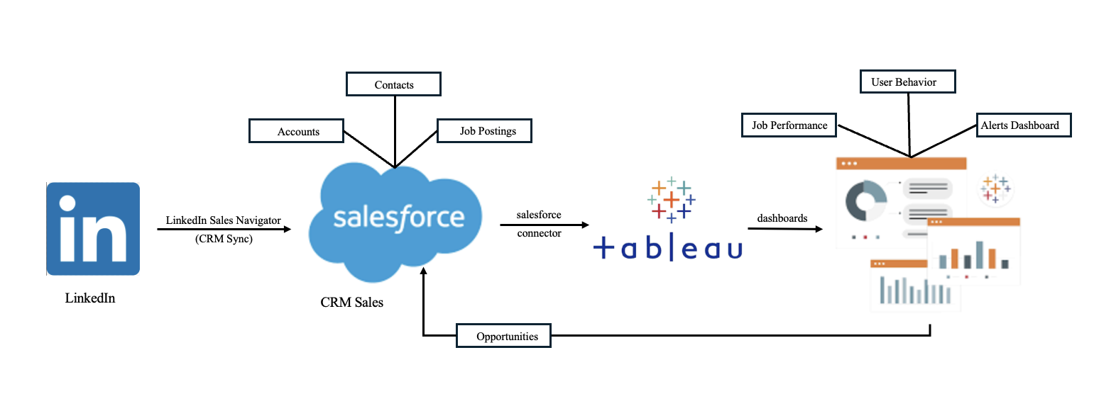
Figure 4: Proposed Business Model
These dashboards provide real-time insights into employer engagement, job performance, and underperforming listings. From these insights, strong sales leads are identified and piped back into Salesforce, where they're assigned to LinkedIn's sales representatives and converted into opportunities. It's a closed-loop, circular process where the intelligence pulled from job activity data continually informs CRM-driven outreach, allowing for smarter decision-making, more focused target targeting, and greater platform ROI.
- DATA MODEL
As illustrated in Figure 5, the data model is built around a central entity, job_postings, which captures detailed information related to each job posting like the job title, company, description, salary details, and application URLs. This table constitutes the core of the schema and is linked to several supporting entities to augment the dataset with contextual details. The benefits and job_skills tables are connected to job_postings via the job_id field, detailing the specific benefits offered and the skill requirements associated with each role. To enable industry-level classification, the model includes a job_industries table that maps jobs to specific sectors through a relationship with the industries table. Company-level attributes such as employee size and follower count are maintained in the employee_counts table, which joins with job_postings through the company_id. Additionally, United States geographic data is handled via the zip_state_mapping table, which links job zip codes to their corresponding states, allowing for location-based filtering and analysis. This normalized and relational schema ensures data consistency, supports scalable querying, and enables multi-dimensional analysis across job-related attributes such as location, skills, benefits, and industry classification.
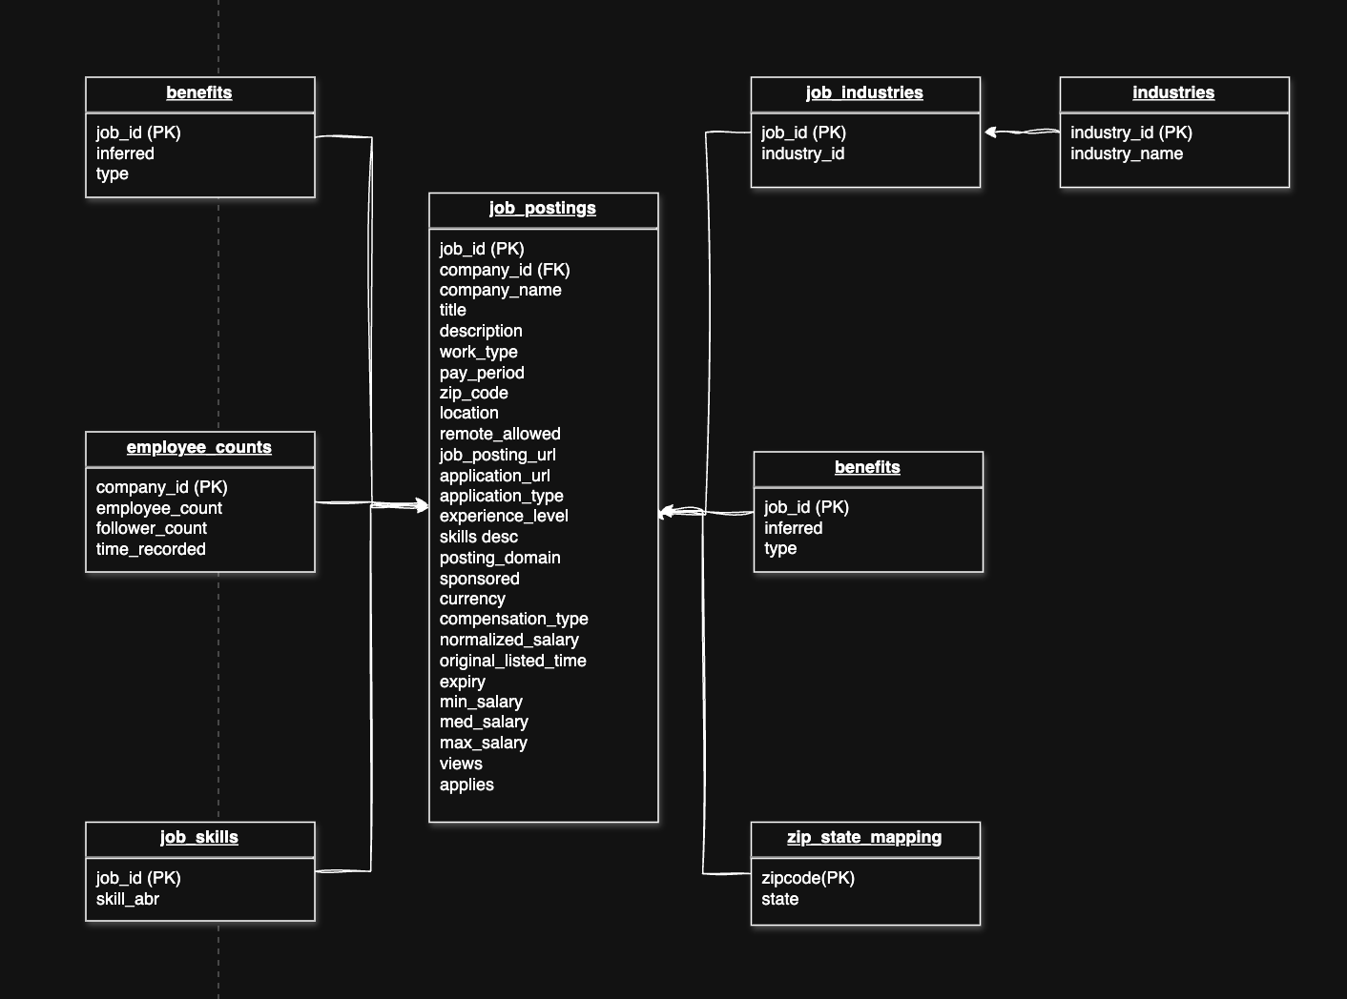
Figure 5: Data Model
For this project, United States ZIP-to-state mapping data was sourced from “RowZero’s ZIP code workbook”. The core LinkedIn job postings dataset, including job-level details such as titles, descriptions, salaries, and application links, was obtained from “Kaggle’s LinkedIn Job Postings dataset”. These datasets were integrated and modeled to support entity relationships and enable robust business intelligence analysis for this project.
PROJECT IMPLEMENTATION REPORT
- TOOLS & FRAMEWORK
Figure 6 illustrates the foundational tools and frameworks that are utilized for the optimization of LinkedIn’s end-to-end project.
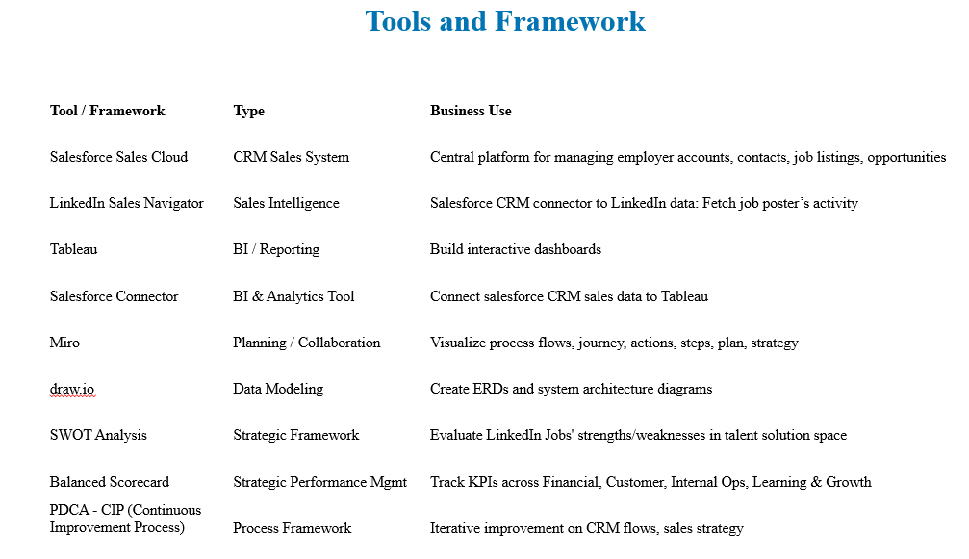
Figure 6: Tools & Framework
- CONTINUOUS IMPORVEMENT PROCESSES
To ensure that the solution as adaptable, scalable, and aligned with LinkedIn's evolving goals over time, a Continuous Improvement Process (CIP) has been embedded within the project's baseline methodology. The process encourages iterative development, performance measurement, and ongoing strategy refinement. Two primary frameworks support this cycle: the SWOT analysis, which defines internal and external drivers to business performance, and the PDCA (Plan-Do-Check-Act) model, which guides implementation and optimization phases within a sequential, data-driven process
SWOT Analysis (Figure 7): The analysis provided the foundation for understanding LinkedIn’s positioning and helped steer the BI and CRM initiatives in the right direction. In terms of strengths, LinkedIn benefits from a large employer base, strong brand credibility, and a rich supply of job activity and engagement data. However, the weaknesses are equally significant—especially the limited adoption of job sponsorships, and the lack of automated lead intelligence and performance insights. On the opportunity side, the project leverages the integration of Salesforce CRM and Tableau BI dashboards to close these gaps. Meanwhile, the threats lie in rising competition from platforms offering stronger analytics, integrated advertising, and streamlined one-click apply options—making it essential for LinkedIn to evolve its strategy continuously to stay competitive.
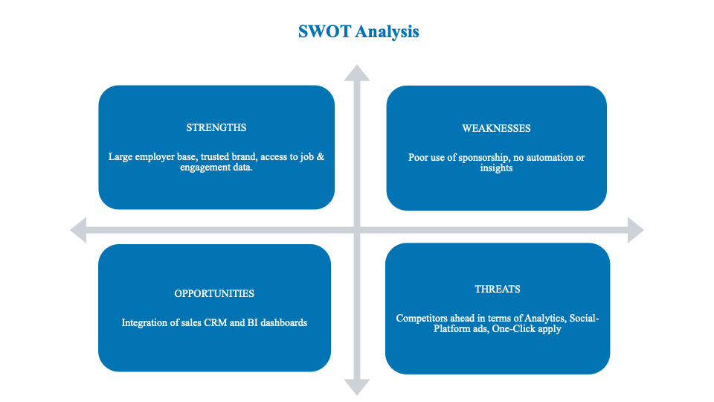
Figure 7: SWOT Analysis
Plan-Do-Check-Act (PDCA – Figure 8): The PDCA cycle serves as a feedback-oriented mechanism that helps convert insights into action. In the Plan phase, root-cause analysis is conducted using the SWOT framework to understand why LinkedIn underperformed in job conversion and employer satisfaction. From this, CRM-related objectives were defined and established measurable Key Performance Indicators (KPIs) around job views, conversion rates, and employer engagement. The Do phase focused on implementation, that included deploying Salesforce CRM Sales to centralize and manage employer-related data and integrating Tableau dashboards to deliver real-time insights into job activity, user behavior, and lead scoring.
In the Check phase, the system continuously tracks performance indicators through the dashboards, enabling teams to monitor metrics like job conversion ratio, employer activity trends, and sponsorship adoption. This monitoring identifies both successful patterns and underperforming areas. Finally, the Act stage involves using these learnings to make continuous improvements, which can involve adjusting KPI targets, tweaking the job sponsorship strategy, or retraining sales teams for greater efficacy with CRM tools. In repeatedly working through this model, LinkedIn not only addresses immediate operational challenges but also develops a sustainable culture of data-driven refinement and strategic adaptability, thus providing continued value to its employer customers and competitive durability amidst an increasingly changing recruitment landscape.
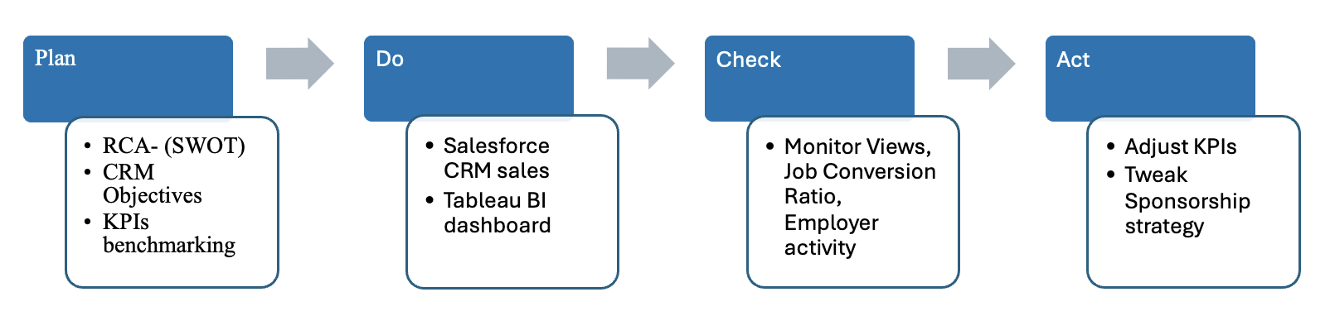
Figure 8: Plan Do Check Act (PDCA)
- IMPLEMENTATION OF SALESFORCE CRM-SALES
A. Capturing Potential Job Leads from LinkedIn
Salesforce plays an important role in capturing job listing data from LinkedIn through a seamless connector integration. Job leads are initially pulled from LinkedIn, where job engagement metrics like views, applications, and company details are mapped into Salesforce’s “Leads” module. These records contain essential details such as the job title, company, contact person, and interaction status. The job lead journey begins with the lead entry and proceeds through qualification stages based on interaction patterns and performance metrics. Figure 9, illustrates a typical lead screen, showing a newly added job post and its current conversion status.
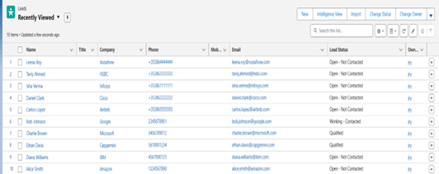
Figure 9: Leads List
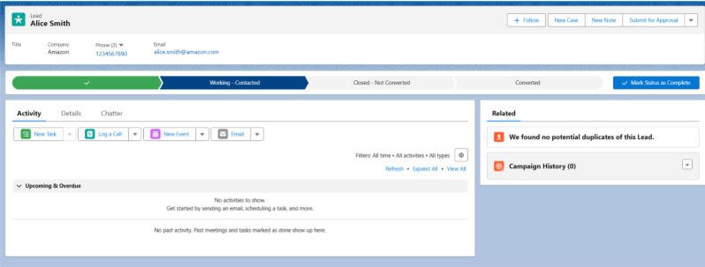
Figure 10: Lead
B. Managing Partner Companies and Client Organizations
Once qualified, job leads from LinkedIn are converted into accounts within Salesforce. These accounts represent partner organizations such as hiring companies or recruitment agencies actively posting jobs through LinkedIn. Salesforce allows tracking of partner activity such as number of job posts, average apply rate, and conversion ratios within the “Accounts” view. It becomes easy to monitor which clients are receiving traction and which require support or outreach. This visibility enables the sales or strategy team to prioritize high-value partnerships and take timely actions.
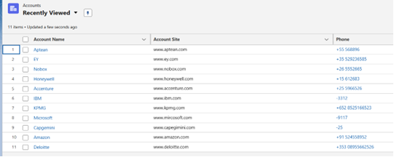
Figure 11: Accounts List
C. Contact Management
Each account includes a set of contacts, representing hiring managers, recruiters, or HR professionals. These contacts are stored in Salesforce’s “Contacts” module, enabling personalized engagement and follow-up. Contact records store names, roles, emails, phone numbers, and interaction history. This structured contact management ensures continuity and context in communication, especially when new opportunities or campaign initiatives comes up.
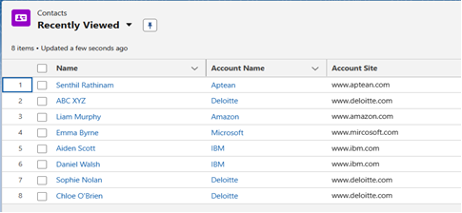
Figure 12: Contacts List
D. Opportunities: Converting Listings into Strategic Deals
Opportunities in Salesforce denote the core business value derived from job leads such as premium listing upgrades, campaign boosts, or employer branding solutions. These opportunities represent potential revenue streams, and each stage in the opportunity pipeline from Needs Analysis to Proposal and Closure is tracked. For example, a job post with high engagement may be flagged as an opportunity for visibility boosting, and the sales team can then initiate a proposal. Salesforce allows tracking expected revenue, close dates, and negotiation stages, ensuring that potential deals are closely monitored and pursued.
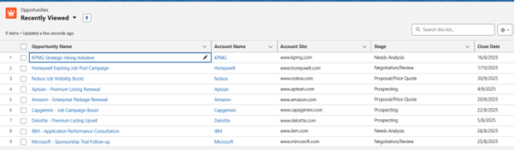 Figure 13: Opportunities List
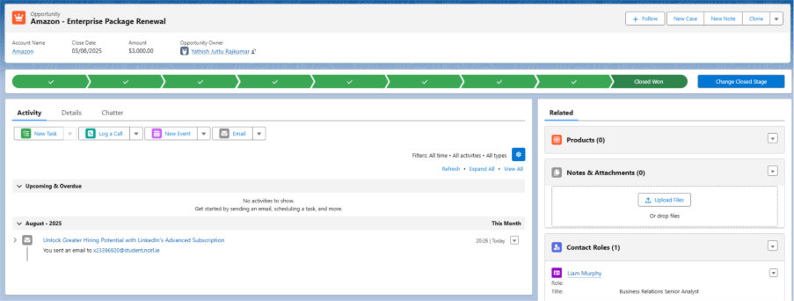 Figure 14: Single Opportunity
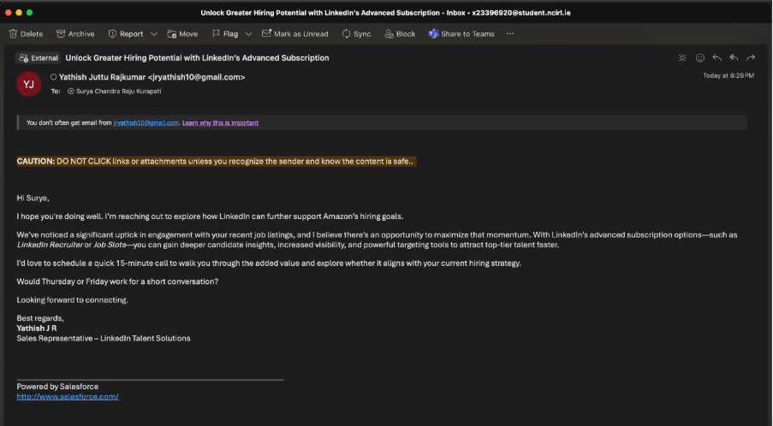
Figure 15: Subscription Purchase Email
The sales opportunity targeted at Surya from Amazon initiated through a personalized outreach email resulted in a successful lead engagement. The email, sent via Salesforce and framed around LinkedIn’s advanced subscription offerings, prompted a positive response from the recipient. This confirms the opportunity’s conversion into a qualified lead, demonstrating the effectiveness of our CRM-driven, data-informed sales strategy.
Salesforce Workflow – From Lead to Opportunity Conversion
Lead Capturing: Job performance insights from Tableau dashboards are reviewed to identify potential clients (e.g., Surya from Amazon). These insights inform the creation of new leads in Salesforce, where key information like company name, contact details, and job interest are recorded.
Lead Qualification: The lead is assessed based on engagement history and job listing trends. If the lead shows high potential (e.g., recent uptick in job posts), it is contacted through a personalized outreach email directly from the Opportunity object in Salesforce.
Opportunity Creation: Once a lead responds positively (as in the Surya–Amazon case), it is converted into an opportunity. The Opportunity record is updated with follow-up details, sales stage (e.g., Prospecting, Proposal), and expected value
Engagement & Follow-Up: Sales reps schedule meetings or calls through Salesforce, log activities (calls, emails, events), and continue engagement using insights from Tableau to tailor messaging and build trust.
Opportunity Outcome: When the opportunity results in a successful engagement (positive reply, interest in LinkedIn subscription), the opportunity is marked as "Closed – Won."
- BALANCE SCORECARD
The Balanced Scorecard system is applied in this project as a strategic management system to map LinkedIn's business goals into key performance indicators (KPIs) under four perspectives: Financial, Customer, Internal Process, and Learning & Growth. In the Financial perspective, the strategic goal is to enhance employer return on investment (ROI) for job postings. KPIs such as Job Conversion Ratio, Application Rate, and Sponsored vs. Organic Performance are employed to assess how effectively job views translate into applications and hires. Additionally, Jobs Nearing Expiry Without Results is used to monitor resource inefficiencies and control costs associated with underperforming listings. In the Customer dimension, the objective is to enhance employer satisfaction and platform engagement. Metrics such as Top Companies by Conversion, Companies with Least Conversion Ratio, and Target Companies for Sponsorship enable identification of high-performing employer accounts and accounts requiring strategic intervention. Other indicators like Top Viewed Job Titles and Benefits Provided help evaluate the attractiveness and relevance of job postings from the candidate’s perspective.
The Internal Process perspective focuses on optimizing the end-to-end job posting lifecycle and enhancing the conversion pathway. KPIs such as Minimum and Maximum Posting Durations, Jobs Trend (Posting Activity), and Application Types are leveraged to evaluate how timing and job structure influence applicant behavior. Furthermore, indicators like Posting Domains, Experience Level Summary, and Application Complexity provide insights into the role of external traffic sources and application design in conversion outcomes. Under the Learning & Growth dimension, the emphasis is placed on market responsiveness and long-term platform adaptability. KPIs such as Top Skills, Industries with Highest Job Volume, and Work Type Mix assist in understanding shifts in industry demand and evolving workforce expectations. Additionally, Views Distribution by State and States with Least Interaction offer actionable insights to support the development of region-specific strategies aimed at improving listing visibility and engagement in underperforming geographic areas. Collectively, the Balanced Scorecard enables a structured, data-driven approach to performance management, ensuring that operational insights directly support LinkedIn’s strategic priorities in talent acquisition and employer engagement.
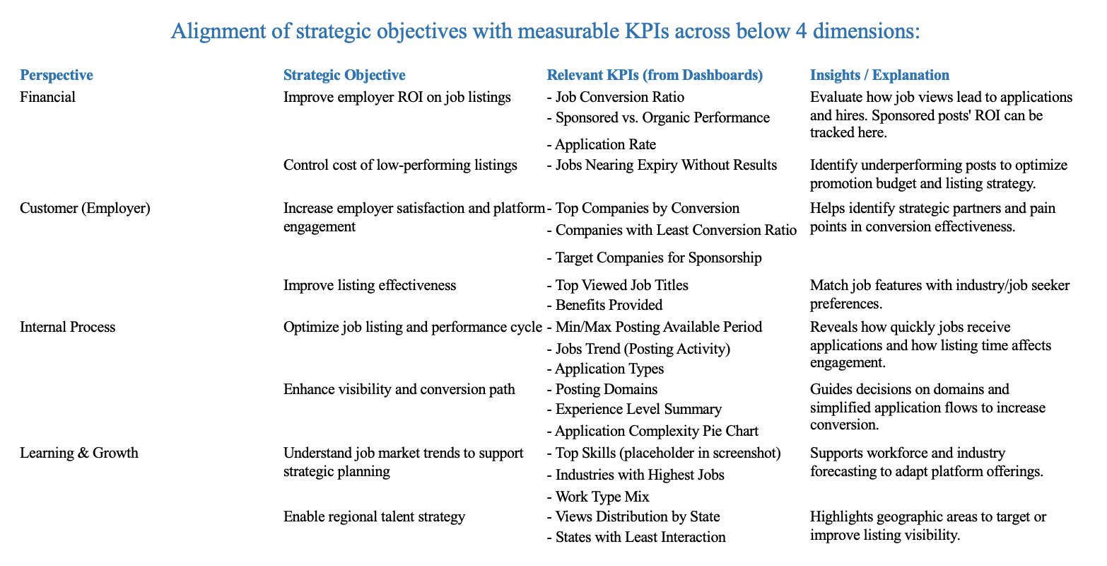
Figure 16: Balance Scorecard
- TABLEAU INSIGHTS
A. Job Performance Dashboard
As illustrated in Figure 17, the Job Performance Dashboard offers a high-level, data-driven overview of recruiting efforts on LinkedIn. It enables recruiters to optimize job posting strategies, improve visibility, and efficiently allocate resources to reduce wasted effort.
Work Type, Pay Period & Benefits: This section of the dashboard breaks down job postings by work type and pay period, key KPIs for understanding how jobs are structured. The data reveals that contract-based jobs, although making up only 10% of total postings, received an average of 7 applications per job, indicating a high conversion rate. In contrast, full-time jobs, which represent 80% of listings, averaged only 2 applications per post, suggesting a mismatch in reach or targeting. Pay period analysis showed 58% of jobs offered yearly salaries, followed by 40% offering hourly compensation. Regarding benefits, 83% of job postings included a 401(k) scheme, and 34% offered medical benefits, underscoring the white-collar nature of these listings.
Top Skills & Top 10 Industries: These KPIs highlight in-demand skills and industries with the most job postings. The Top Skills chart includes "ServiceNow," "Salesforce," "Python," and "Project Management" as leading requirements. In the Top 10 Industries, Hospitals and Healthcare led with 30% of job postings, followed by Retail and IT Services & Consulting, each accounting for 16%. These insights inform targeted outreach and recruitment strategies, especially by industry verticals.
Top 5 States & Posting Domain: This section provides a geographic and source-based breakdown. The Top 5 States bubble chart identifies New York and Texas as high-performing job markets, emphasizing the need to prioritize employer marketing and sponsorship efforts in these states. Domain-level traffic analysis showed click2apply.net (24%), click.appcast.io (14%), and jsv3.recruitics.com (12%) as the top external sources driving traffic to LinkedIn job postings, helping inform syndication and ad partnership strategies.
Experience Level Summary & Jobs Trend: This section covers job posting distribution by experience level and temporal performance trends. Jobs were categorized into tiers such as "Mid-Senior Level" and "Entry-Level", offering insight into target talent pools. Job duration data revealed significant variance—from just 4 days for some mid-senior roles to as many as 205 days for roles in the healthcare sector. This led to the implementation of automatic expiry alerts and reposting recommendations. The Jobs Trend chart showed a clear spike in postings during mid-April 2024, revealing peak hiring cycles and enabling better campaign planning around those windows.
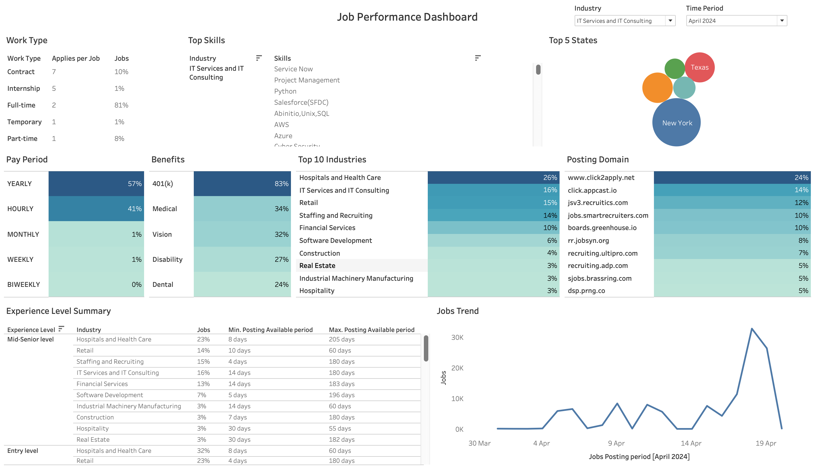

Figure 17: Job Performance Dashboard

B. User Behavior Dashboard
As illustrated in Figure 18, the User Behavior Dashboard is designed to analyze how job seekers interact with various job postings and employers. This dashboard provides valuable insights for both the product and marketing teams, helping them better understand user preferences, optimize the job application experience, and inform campaign strategies.
Top 10 Most Viewed Job Titles: This KPI highlights the roles that attracted the most user attention. The Customer Success Manager position led with 6.2K views, followed by Customer Operations – Talent Community with 5.7K views, and Customer Success Associate with 4.0K views. These metrics help recruiters and account managers identify which job titles generate the most interest, allowing them to align their outreach strategies and job recommendations accordingly.
Average Views per Job Work Type: This chart revealed that contract-based jobs received the highest average visibility at 32 views per posting, followed by internships at 23 views, and full-time roles at 13 views. Despite being less common, contract roles captured more attention per listing, suggesting a strong case for promoting these job types in sponsorship campaigns and personalized recommendations.
Top 10 Companies with High Job Conversion Ratio: This KPI focused on employer performance by measuring conversion rate (applies/views). Zact ranked highest with a 48.9% conversion rate, followed closely by Gaze and Future Work Systems LLC, both at 43.4%, primarily within the Software Development sector. These companies demonstrate strong alignment between job posts and applicant intent, making them ideal candidates for upselling advanced recruitment features and personalized engagement solutions.
Applications by Application Type: In terms of application methods, many users (66.68%) opted for Standard and Detailed Apply flows, followed by 26.67% using External Company Site Apply, and only 6.65% using Easy or Quick Apply. This trend suggests that job seekers, especially on a professional platform like LinkedIn, may prefer detailed application processes aligned with more formal or white-collar roles.
User Views Distribution by State: The geographic heat map of job seeker activity showed that New York accounted for 45.61% of views, followed by California at 7.93%. These insights provide a strong foundation for region-specific sponsorship efforts, employer outreach, and strategic listing placements in high-traffic states.
User Summary Insights: The dashboard also includes a detailed table summarizing key metrics for each listing covering Industry, Employer, Job Title, Listing Duration, View Count, and Application Volume. For example, a Frontend Engineer role at Gaze under the Software Development industry received 935 views and 406 applications, indicating exceptional conversion performance. Similarly, the Cloud DevOps Engineer position at Zact saw 264 applications from 540 views, reinforcing the employer's effectiveness in attracting relevant candidates.
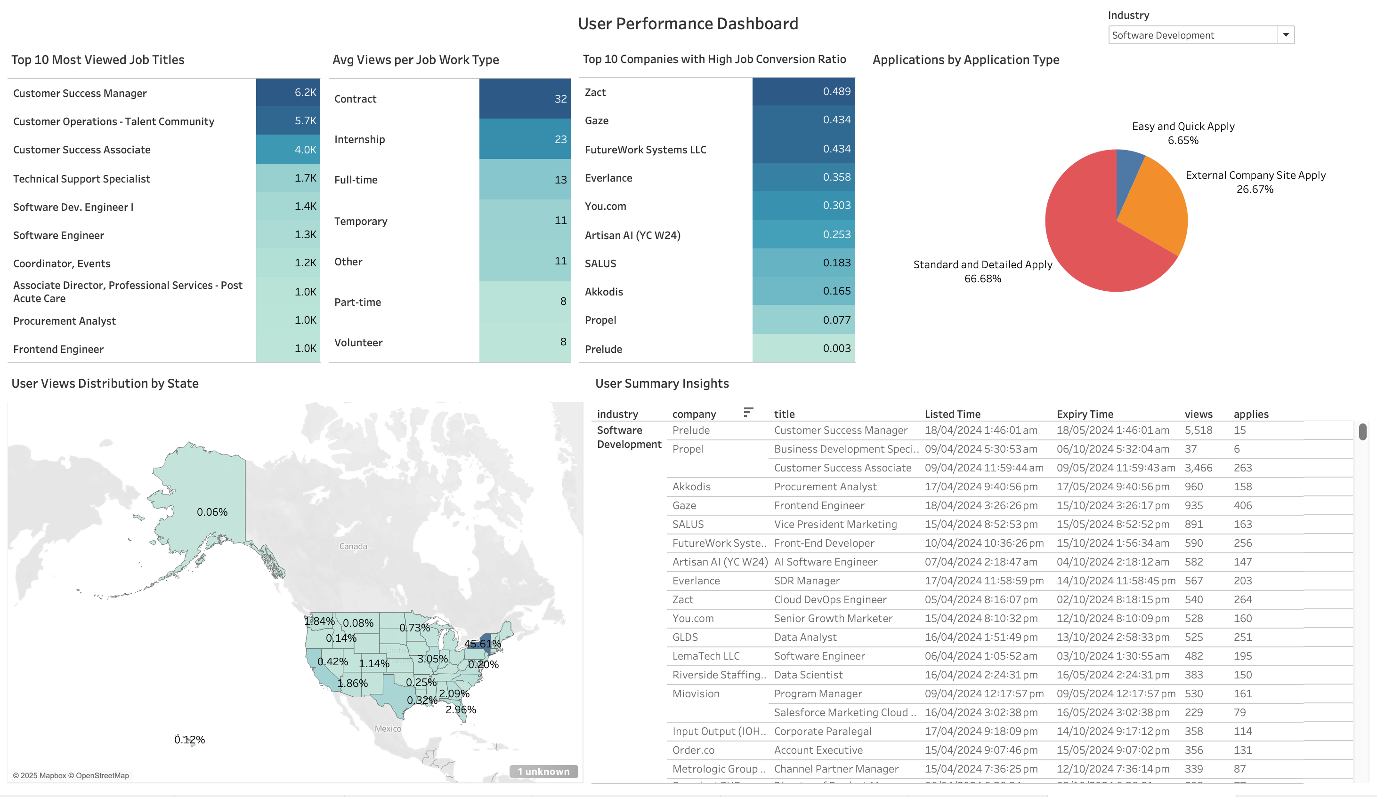
Figure 18: User Behavior Dashboard
C. Alerts Dashboard
As illustrated in Figure 19, the Alerts Dashboard is designed to provide real-time visibility into employer accounts and job listings that require immediate attention due to low engagement, underperformance, or impending expiration. This dashboard acts as a decision-support tool for sales representatives, enabling them to identify underperforming clients and listings and take proactive action to boost platform ROI.
Companies with least Job Conversion Ratio: A heatmap within the dashboard highlights employers such as Amperity, Workday, Atlassian, DealHub.io, and JFrog, which recorded the lowest conversion ratios measured by applies per view. For instance, Amperity had job listings active for 62 days with only 1 application from 10 views, signaling a serious performance gap. These insights trigger alerts for sales reps to engage the employer and propose upgrades to premium or sponsored listings.
Jobs trend past 30 days: This line chart tracks posting activity by work type over the last month, revealing a noticeable mid-month spike in full-time job postings. Such trends help sales teams time their support calls, follow-up emails, or outreach campaigns to align with peak activity windows.
Experience Level Distribution: This overview segment breaks down job engagement by experience level. Mid-Senior Level roles drew the most attention with 636K views and 103K applications, while Entry-Level positions, despite receiving 301K views, only converted 23K applications, suggesting a disconnect between visibility and applicant interest. This may indicate the need for better targeting, clearer job descriptions, or refined application processes.
Target Companies for Sponsorship: A bubble chart pinpoints companies with high-traffic job listings such as PointClickCare (8.4K views), Prelude (5.5K views), and Amazon (4.8K views). These organizations show strong engagement but are not yet on sponsorship plans, making them ideal candidates for sales teams to approach with sponsorship packages to further amplify visibility.
Jobs Nearing Expiration: This list identifies job postings nearing 300 days of inactivity with minimal traction. Employers like GibsonAI, Syndica, Arcus, LiveFlow, and Salesbricks had stale listings, triggering automated renewal reminders and campaign suggestions within Salesforce to help improve listing performance and avoid client churn.
States with Least Job Interactions: A geospatial map showcases U.S. states with the lowest user engagement, including South Dakota (0.1%), Maine (0.2%), District of Columbia (0.7%), and Alaska (0.1%). These low-performing regions serve as strategic touchpoints for sales representatives to engage employers with tailored premium offerings, helping improve visibility and conversion in underperforming geographies.
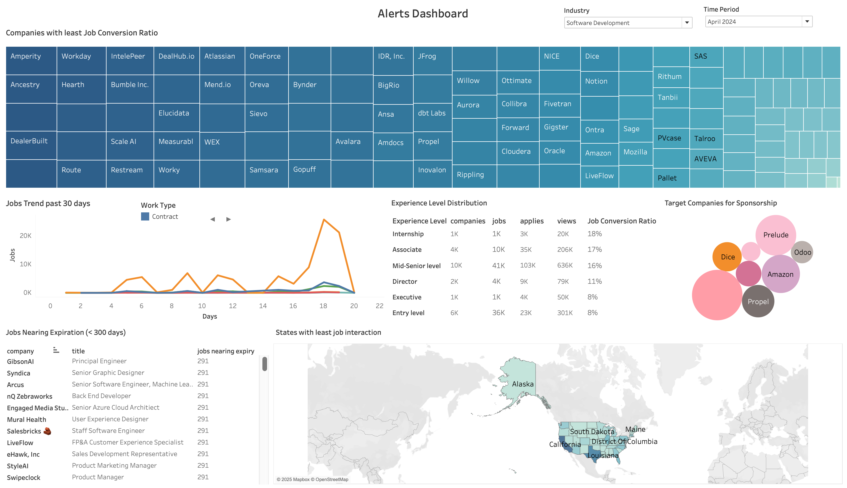
Figure 19: Alerts Dashboard
- FINAL OUTCOME AND STRATEGY TAKEAWAY FOR BUSINESS
As part of the final strategic implementation, the proposed business intelligence solution has been designed to support differentiated outcomes for key user roles across LinkedIn’s B2B sales and recruitment ecosystem. Sales and account representatives are now equipped with real-time visibility into employer activity, enabling them to proactively follow up on underperforming job listings and identify opportunities to upsell premium offerings. Recruiters and employers benefit from embedded Tableau dashboards, providing access to listing-level insights and automated performance suggestions that support more effective job post optimization. The marketing team leverages behavioral and conversion data to design targeted campaigns, aimed at client retention and promoting the adoption of sponsored listings. Meanwhile, executive stakeholders gain access to high-level dashboards that present metrics on churn rates, ROI performance, and overall platform engagement, enabling more strategic decision-making at the organizational level. This role-specific enablement ensures that data insights are not only accessible but actionable, aligning with LinkedIn’s broader strategy of driving operational efficiency, improving employer satisfaction, and maximizing ROI through targeted, intelligence-driven interventions.
Table 2: Outcome and Strategy takeaway for business
User Role | Key Activities
Sales/Account Reps | Monitor employer activity, follow up on poor listings, upsell premium
Recruiters (Employers) | View listing insights (embedded Tableau), receive automated suggestions
Marketing Team | Run campaigns to retain clients or promote sponsorship
Executives | View platform-wide dashboards on churn, ROI, engagement
- TEAM
The project was executed by LinkedIn consultant team, each contributing to optimize B2B sales performance through a data-driven business intelligence framework. Surya Kurapati led the root cause analysis using SWOT analysis and the PDCA-based CIP for strategic approach. He also designed the Tableau wireframes aligned with the Balanced Scorecard and built the three final interactive dashboards. Yathish Juttu Rajkumar managed the data collection, implemented the Salesforce CRM Sales integration, and created CRM structures enabling seamless interaction between insights and sales processes. Saranya Munikannaih directed the development of the specification and implementation report. For the purpose of maintaining seamless coordination and timely completion, the team followed task management on Miro, timelines were set, and a 4-week strategic plan was created. This organized work flow allowed the team to effectively manage time, coordinate deliverables, and complete each stage of the project with accuracy and effect.
Miro Board – Enhance B2B sales outreach at LinkedIn - Miro
Trello – Project Overview | Trello
Presentation - LinkedIn-BIBA-Presentation Final.pptx

REFERENCES
Business Model Analyst. (n.d.). LinkedIn business model. Retrieved August 3, 2025, from https://businessmodelanalyst.com/linkedin-business-model/
LinkedIn. (2014). Platform overview [PDF]. Retrieved August 3, 2025, from https://business.linkedin.com/content/dam/me/business/en-us/marketing-solutions/resources/pdfs/Platform-Overview-v03.14.pdf
LinkedIn. (n.d.). B2B vs B2C marketing. Retrieved August 3, 2025, from https://business.linkedin.com/marketing-solutions/success/marketing-terms/b2b-vs-b2c
LinkedIn. (n.d.). LinkedIn vs competitors: Talent acquisition resource. Retrieved August 3, 2025, from https://business.linkedin.com/talent-solutions/resources/talent-acquisition/linkedin-vs-competitors
LinkedIn. (n.d.). Post a Job on LinkedIn | Hiring on LinkedIn. Retrieved August 3, 2025, from https://business.linkedin.com/talent-solutions/post-jobs
LinkedIn. (n.d.). Premium Career Features | LinkedIn Premium. Retrieved August 3, 2025, from https://premium.linkedin.com/careers/career
R. Choudhury and A. Pattnaik, “Improving CRM through AI and BI integration,” International Journal of Business Intelligence Research, vol. 11, no. 1, pp. 23–35, 2020.

L. Li and H. Zheng, “A study on lead conversion and opportunity management using Salesforce CRM,” Journal of Business Management Studies, vol. 7, no. 3, pp. 48–55, 2020

T. Nguyen, “Business Intelligence integration with Salesforce for marketing optimization,” Journal of Data-Driven Decision Making, vol. 4, no. 3, pp. 14–26, 2023.

